**Lecture 14.**

**Concavity and Points of Inflection. Asymptotes.**

**The Direction of Concavity. Points of Inflection**. We say that the graph of a differentiable function $f\left(x\right)$ is *concave down* in the interval $(a,b)$ if for $a<x<b$ the arc of the curve is below the tangent drawn at any poin of the interval $\left(a,b\right).$ We say that the graph of a differentiable function $f\left(x\right)$ is *concave up* in the interval $(a,b)$ if for $a<x<b$ the arc of the curve is above the tangent drawn at any point of the interval $\left(a,b\right).$

A sufficient condition for the concavity downwards (upwards) of a graph  is that the following inequality be fulfilled in the appropriate interval: 

**Points of inflection.** A point  at which the direction of concavity of the graph of some function changes is called *a point of inflection*. For the abscissa of the point of inflection  of the graph of a function  there is no second derivative 

Points at which  or  does not exist are called critical points of the second kind. The critical points of the second kind $x_{0}$ is the abscissa of the point of inflection if  retains constant signs in the intervals  and  where $δ$ is some positive number; provided these signs are opposite. And it is not a point of inflection if the signs of  are the same in the above-indicated intervals.

**Asymptotes.** If a point $(x,y)$ is in continuous motion along a curve $y=f(x)$ in such a way that at least one of its coordinates approaches infinity (and at the same time the distance of the point from some straight line tends to zero), then this straight line is called an *asymptote* of the curve.

**Vertical asymptotes**. If there is a number $a$ such that

 (9)

Then straight line $x=a$ is an asymptote (vertical asymptote**).**

**Example.** Weknow that as

$x→\frac{π}{2}+0$, $tgx→-∞,$

and as

$x→\frac{π}{2}-0,$ $tgx→+∞.$

Therefore, the line $x=\frac{π}{2}$ is a vertical asymptote.

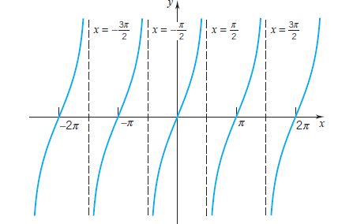

In fact, the lines *x* = (2*n* + 1)*π/*2*, n* = 0*,*±1*,*±2*, . . .*, are all vertical asymptotes for the tangent function.

**Example. $f\left(x\right)=\frac{cosx}{x}, x>0.$**

As $x→0+, cosx→1 and \frac{1}{x}→∞,$ and

$$f\left(x\right)=\frac{cosx}{x}=cosx∙\frac{1}{x}→∞.$$

The line $x=0$ (y-axis) is a vertical asymptote.



**Inclined asymptotes.** If there are limits

 (10)

and

 (11)

then the straight line

 (12)

will be an asymptote.